 

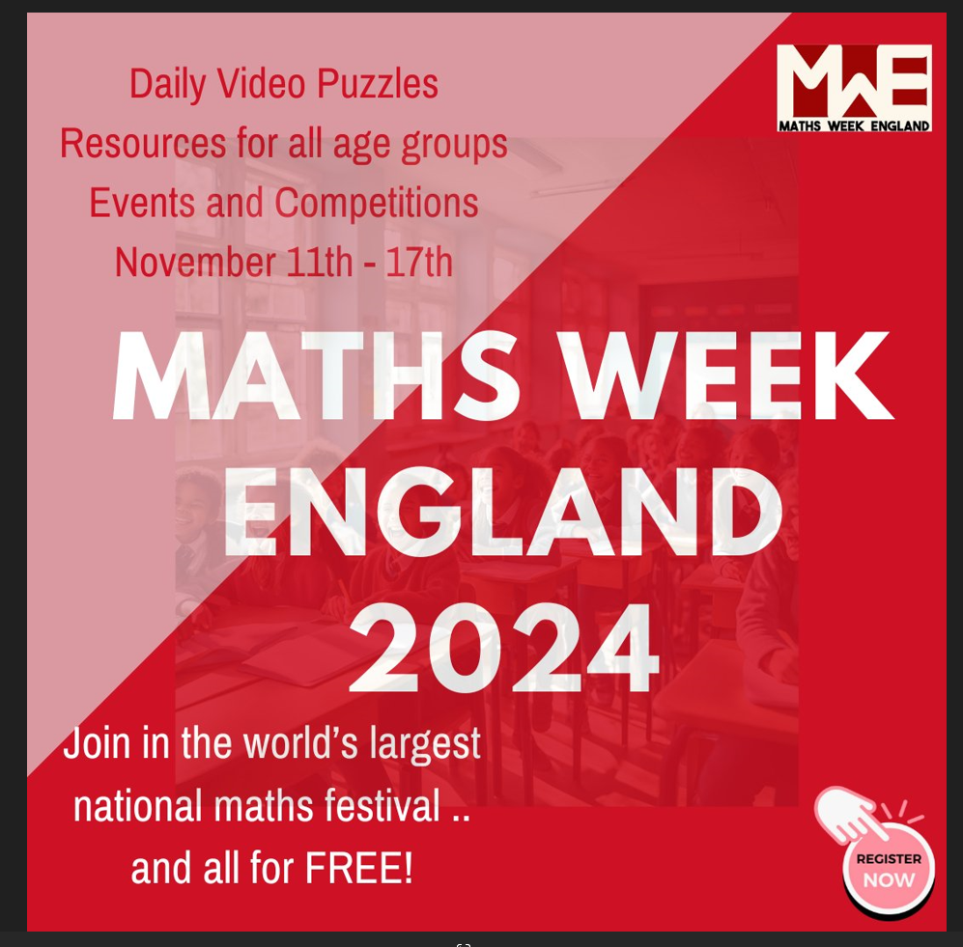

Next week 11th Novemeber- 17th Novemeber 2024 is Maths Week England

Try to do some of the puzzles attached!!

#MathsWeekEngland

 

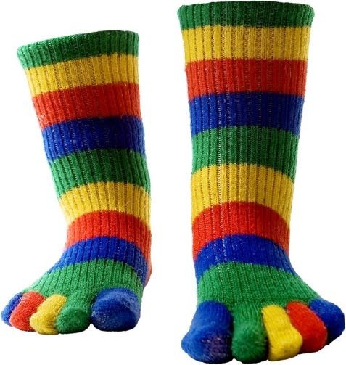

SOCKS!

**Cath has 31 socks in**

**her drawer. There are 11 identical blue , 8 identical red and**

**12 identical black.**

**The lights aren’t working and it is pitch black.**

**How many socks must Cath take from the drawer to guarantee that she will have at least one pair of each colour?**



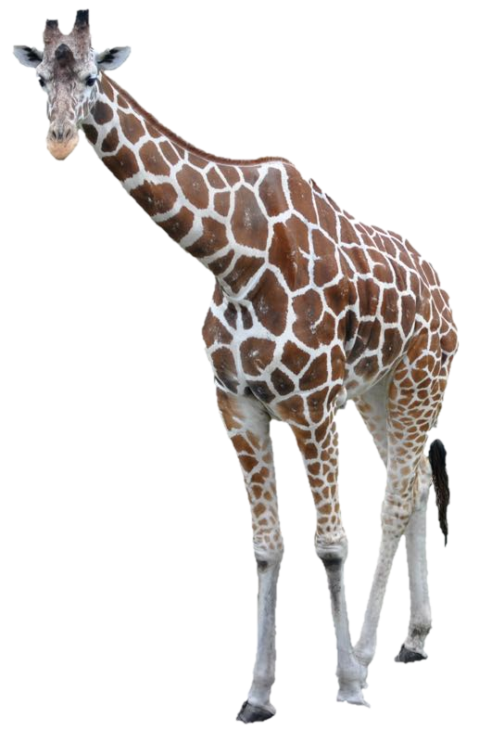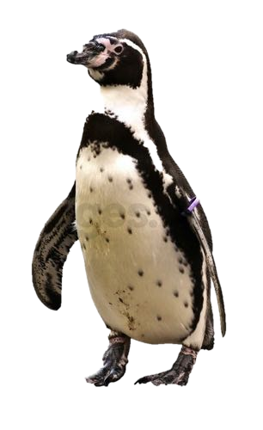

# THE ZOO!

**The Zoo has a total of 29 giraffes and penguins. They are all perfect specimens.**

**They have 84 legs in total.**

**How many giraffes and how many penguins are there?**





BRICKS

**The number on each brick is the sum of the numbers on the two bricks below it.**

**7**

**?**

**?**

**10**

**?**

**?**

**5**

**?**

**?**

**45**

**Can you find the missing numbers?**



# THE RACE!

Posh, Scary, Sporty, Baby and Ginger had a race.

Posh beat Scary by as many places as Baby beat Ginger.

Neither Sporty or Ginger were 3rd or 5th.

**In what order did they finish?**

# TREASURE MAP!



Louisiana Smith is an archaeologist with a treasure map. She knows she has to tread on each stone once in the correct order before getting to the treasure.



|  |  |  |  |
| --- | --- | --- | --- |
| ***4*** |  | ***6*** | ***1*** |
| ***8*** | ***3*** | ***2*** | ***2*** |
| ***9*** | ***2*** | ***4*** | ***4*** |
| ***1*** | ***6*** | ***9*** | ***8*** |

**Can you spot a logical sequence she should take?**